McKenzie Payne

Week Five and Six - DSC 640

1 scatterplot, 1 bubble chart and 1 density map using Tableau or PowerBI

1 scatterplot, 1 bubble chart and 1 density plot chart using Python

1 scatterplot, 1 bubble chart and 1 density plot chart using R

Using Power BI

Scatter Plot:

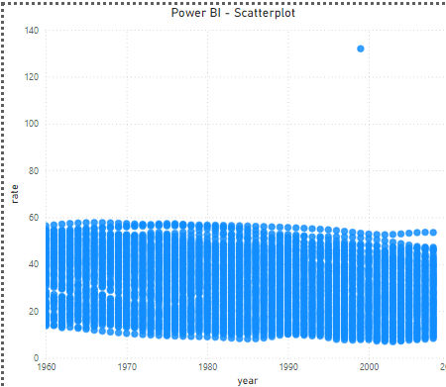

Bubble Chart

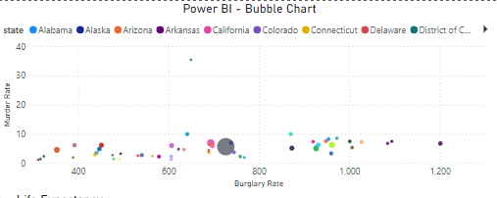

Density Map

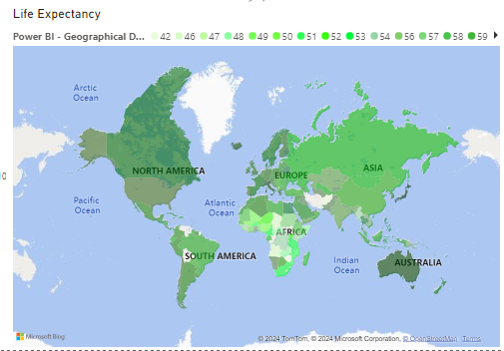

Using R:

**Scatterplot (R)**

In [2]:

*# Scatterplot (R)*

print(ggplot(birth_rates_yearly, aes(x **=** year, y **=** rate)) **+**

geom_point() **+**

ggtitle("R - Scatterplot") **+**

xlab("Year") **+**

ylab("Birth Rate"))

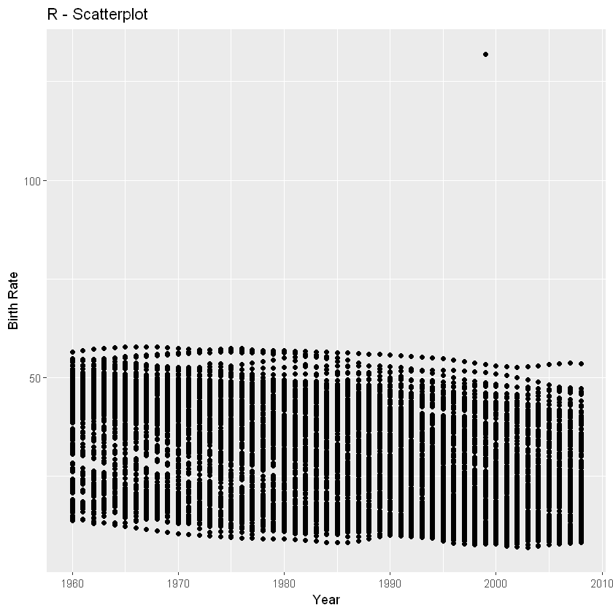

### Density Plot (R)

In [3]:

*# Density Plot (R)*

print(ggplot(life_expectancy, aes(x **=** expectancy)) **+**

geom_density(fill **=** "blue", alpha **=** 0.5) **+**

ggtitle("R - Density Plot") **+**

xlab("Life Expectancy"))

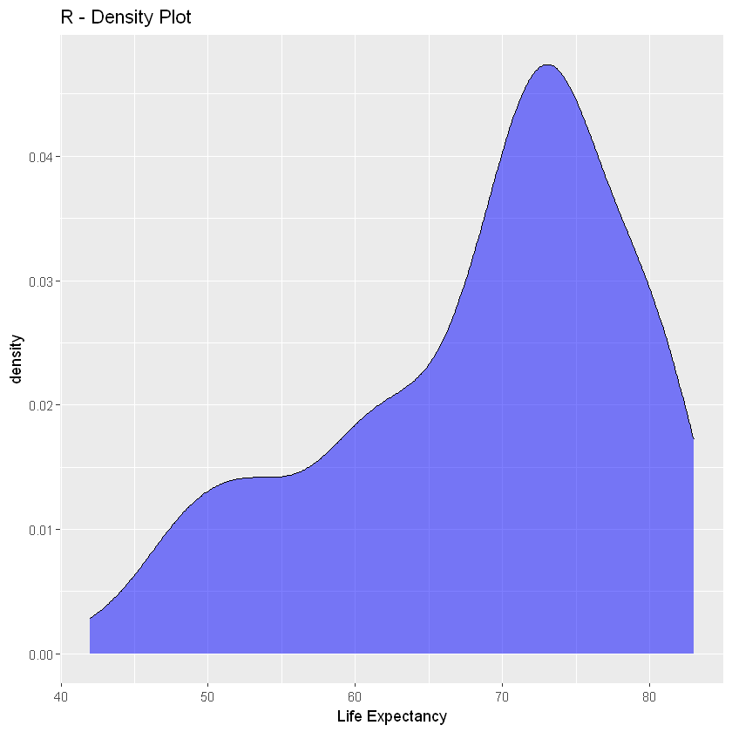

### Bubble Chart (R)

In [4]:

*# Bubble Chart (R)*

print(ggplot(crime_rates, aes(x **=** state, y **=** murder, size **=** population, color **=** state)) **+**

geom_point(alpha **=** 0.5) **+**

ggtitle("R - Bubble Chart") **+**

xlab("State") **+**

ylab("Murder Rate"))

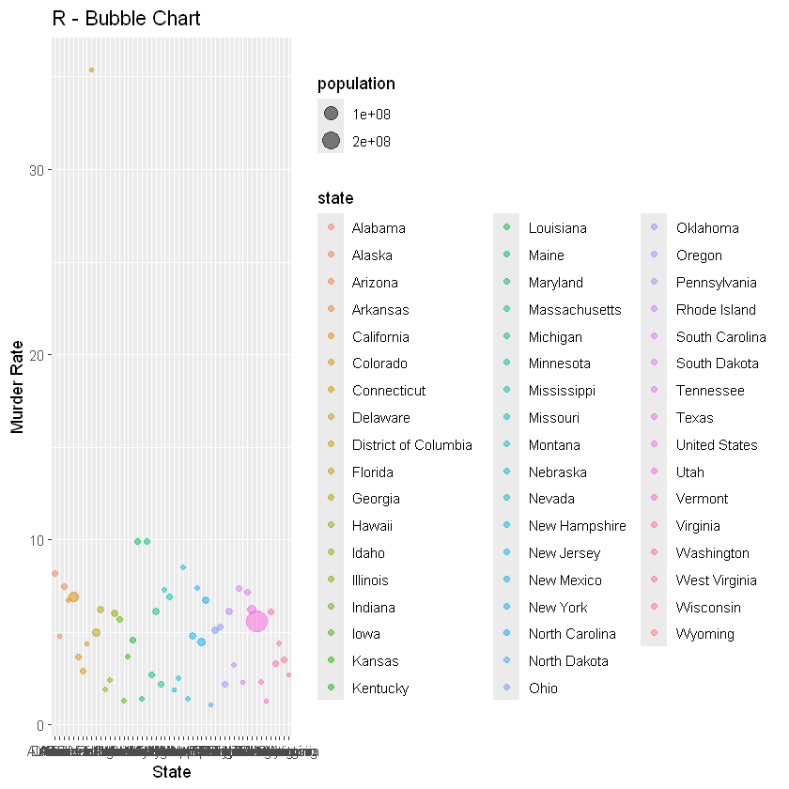

In [ ]:

Using Python:

*# Scatterplot (Python)*

plt**.**figure(figsize**=**(10, 6))

sns**.**scatterplot(data**=**birth_rates_yearly, x**=**'year', y**=**'rate')

plt**.**title('Python - Scatterplot')

plt**.**xlabel('Year')

plt**.**ylabel('Birth Rate')

plt**.**savefig('Python_Scatterplot.png')

plt**.**show()

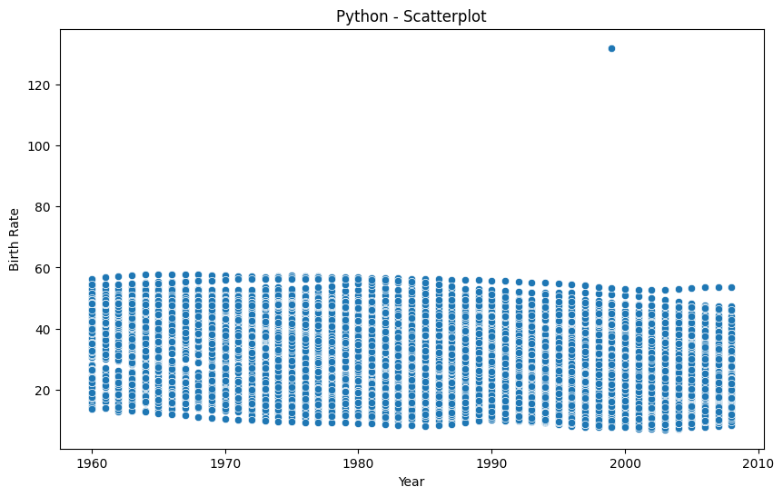

### Bubble Chart (Python)

In [ ]:

fig **=** px**.**scatter(crime_rates, x**=**'state', y**=**'murder', size**=**'population', color**=**'state',

title**=**'Python - Bubble Chart')

fig**.**update_layout(xaxis_title**=**'State', yaxis_title**=**'Murder Rate')

fig**.**show()

fig**.**write_image('Python_Bubble_Chart.png')

United StatesAlabamaAlaskaArizonaArkansasCaliforniaColoradoConnecticutDelawareDistrict of ColumbiaFloridaGeorgiaHawaiiIdahoIllinoisIndianaIowaKansasKentuckyLouisianaMaineMarylandMassachusettsMichiganMinnesotaMississippiMissouriMontanaNebraskaNevadaNew HampshireNew JerseyNew MexicoNew YorkNorth CarolinaNorth DakotaOhioOklahomaOregonPennsylvaniaRhode IslandSouth CarolinaSouth DakotaTennesseeTexasUtahVermontVirginiaWashingtonWest VirginiaWisconsinWyoming0102030

stateUnited StatesAlabamaAlaskaArizonaArkansasCaliforniaColoradoConnecticutDelawareDistrict of ColumbiaFloridaGeorgiaHawaiiIdahoIllinoisIndianaIowaKansasKentuckyLouisianaMaineMarylandMassachusettsMichiganMinnesotaMississippiMissouriMontanaNebraskaNevadaNew HampshireNew JerseyNew MexicoNew YorkNorth CarolinaNorth DakotaOhioOklahomaOregonPennsylvaniaRhode IslandSouth CarolinaSouth DakotaTennesseeTexasUtahVermontVirginiaWashingtonWest VirginiaWisconsinWyomingPython - Bubble ChartStateMurder Rate

In [3]:

*# Density Plot (Python)*

plt**.**figure(figsize**=**(10, 6))

sns**.**kdeplot(data**=**life_expectancy['expectancy'], fill**=True**)

plt**.**title('Python - Density Plot')

plt**.**xlabel('Life Expectancy')

plt**.**savefig('Python_Density_Plot.png')

plt**.**show()

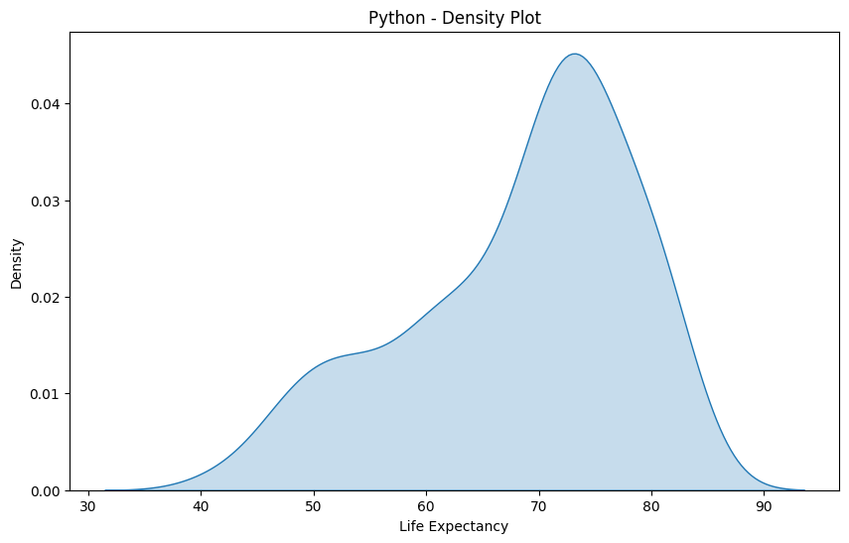

In [ ]: